Localization Resource

📝Definition
# Source: AI Source: Provided by: [Data Path: Persons Table -> ID Column: 1, Name_En Column: Motasem Essam] -> From: [ChatGPT] on [1/23/2026]
A Localization Resource is a set of language-specific strings and messages that an application uses to display content in different languages or regions. It separates text content from code, making the app multi-lingual and maintainable.
Think of it as a dictionary or translation map for your app.

🔑 Key Points
# Source: AI Source: Provided by: [Data Path: Persons Table -> ID Column: 1, Name_En Column: Motasem Essam] -> From: [ChatGPT] on [1/23/2026]
- Stores all text displayed to users (labels, messages, notifications)
- Supports multiple languages without changing code
- Helps internationalization (i18n) and accessibility
- Can be JSON, PHP arrays, XML, or YAML, depending on the framework

🧱 Examples

1️⃣ JavaScript Example
# Source: AI Source: Provided by: [Data Path: Persons Table -> ID Column: 1, Name_En Column: Motasem Essam] -> From: [ChatGPT] on [1/23/2026]
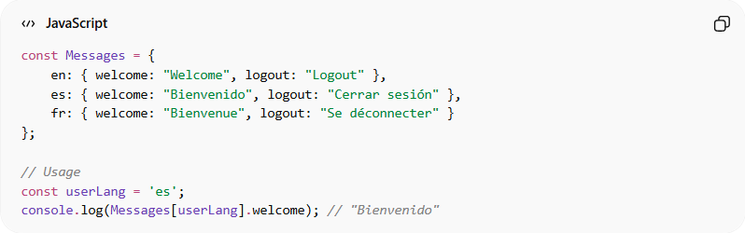
const Messages = {
en: { welcome: "Welcome", logout: "Logout" },
es: { welcome: "Bienvenido", logout: "Cerrar sesión" },
fr: { welcome: "Bienvenue", logout: "Se déconnecter" }
};

// Usage
const userLang = 'es';
console.log(Messages[userLang].welcome); // "Bienvenido"
- Provides consistent text across the app
- Easy to add new languages without touching core code

2️⃣ Laravel Example
# Source: AI Source: Provided by: [Data Path: Persons Table -> ID Column: 1, Name_En Column: Motasem Essam] -> From: [ChatGPT] on [1/23/2026]
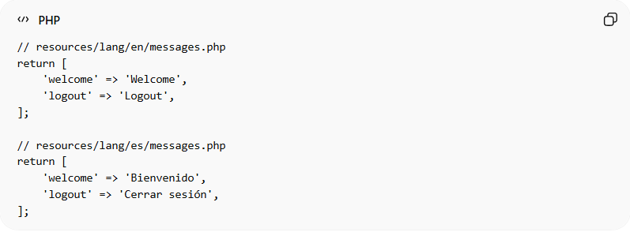
// resources/lang/en/messages.php
return [
'welcome' => 'Welcome',
'logout' => 'Logout',
];

// resources/lang/es/messages.php
return [
'welcome' => 'Bienvenido',
'logout' => 'Cerrar sesión',
];
Usage in Blade Template or Controller:
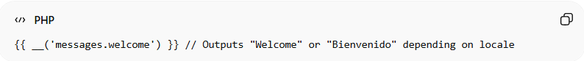
{{ __('messages.welcome') }} // Outputs "Welcome" or "Bienvenido" depending on locale
- Laravel automatically loads the correct language based on locale
- Keeps UI text separate from business logic

❌ Bad Example
# Source: AI Source: Provided by: [Data Path: Persons Table -> ID Column: 1, Name_En Column: Motasem Essam] -> From: [ChatGPT] on [1/23/2026]
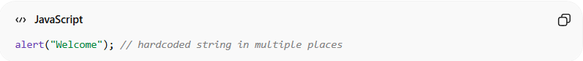
alert("Welcome"); // hardcoded string in multiple places
Problems:
- Difficult to translate
- Inconsistent text across the app
- Breaks DRY principle

✅ Good Example
# Source: AI Source: Provided by: [Data Path: Persons Table -> ID Column: 1, Name_En Column: Motasem Essam] -> From: [ChatGPT] on [1/23/2026]
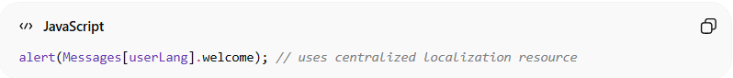
alert(Messages[userLang].welcome); // uses centralized localization resource
- Text is centralized and maintainable
- Adding languages is easy
- Keeps code clean and reusable

💡 Summary:
# Source: AI Source: Provided by: [Data Path: Persons Table -> ID Column: 1, Name_En Column: Motasem Essam] -> From: [ChatGPT] on [1/23/2026]
A Localization Resource centralizes all user-facing text, making the application multi-lingual, consistent, and maintainable.

